SIMPLE DEVELOPMENT FUNDAMENTAL-II

ASSIGNMENT 1

1.

|  |  |
| --- | --- |
| C STRUCTURE | C++ STRUCTURE |
| IN C WE CANNOT HAVE MEMBER FUNCTIONS INSIDE STRUCTURE. | IN C++ WE CAN HAVE MEMBER FUNCTIONS INSIDE STRUCTURE. |
| WE CANNOT DIRECTLY INITIALISE THE STRUCTURE DATA IN C | WE CAN DIRECTLY INITIALISE THE STRUCTURE DATA IN C++ |
| C STRUCTURE CANNOT HAVE STATIC VARIABLE | C STRUCTURE CAN HAVE STATIC VARIABLE |
| THE SIZE OF OPERATOR WILL GENERATE 0 FOR EMPTY STRUCTURE | THE SIZE OF OPERATOR WILL GENERATE 1 FOR EMPTY STRUCTURE |
| C STRUCTURE DOES NOT HAVE ACCESS MODIFIERS | C++ HAVE ACCESS MODIFIERS |

EXAMPLES-

C program

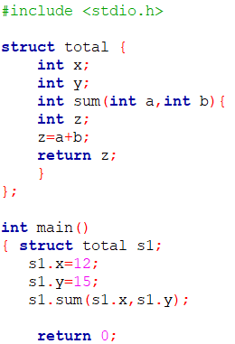

C++ program

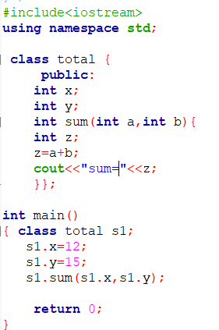

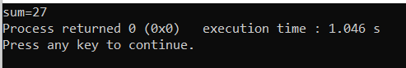

C program

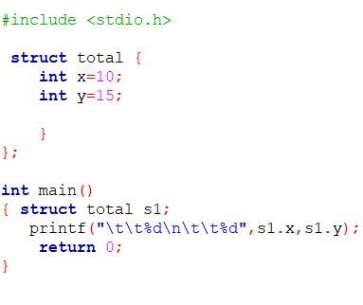

C++ program

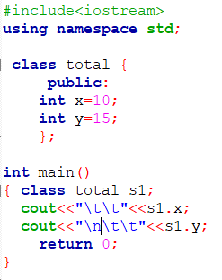

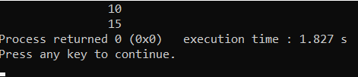

C program

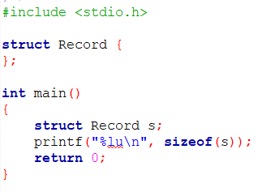

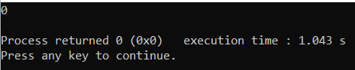

C++ program

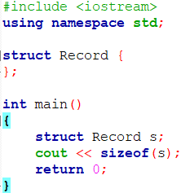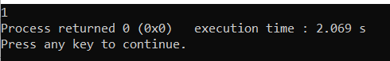

C program

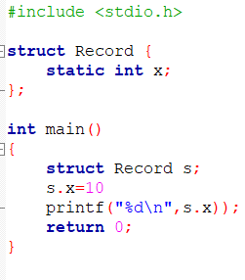

C++ program

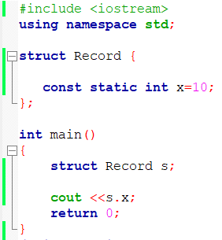

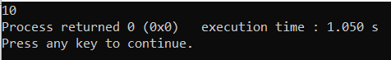

Ques 2.

Soln. a





2.b



